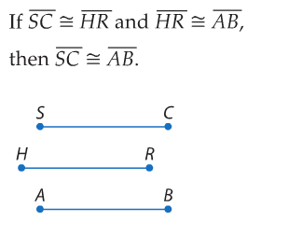9.

|  |  |
| --- | --- |
| Statements | Reasons |
|  | 1. Given |
|  | 2. Transitive Property of Congruence |

|  |  |
| --- | --- |
| Statements | Reasons |
|  | 1. Given |
|  | 2. Definition of Congruent Segments |
| 1. Y, W, V and V, X, Z are collinear | 3. Assumed by Diagram |
| 1. WY + VW = VY   XZ + VX = VZ | 4. Segment Addition Postulate |
| 1. XZ + VX = WY + VW | 5. Substitution Property |
| 1. WY + VX = WY + VW | 6. Substitution Property |
| 1. VX = VW | 7. Subtraction Property |
| 1. VW = VX | 8. Symmetric Property |
|  | 9. Definition of Congruent Segments |

10.

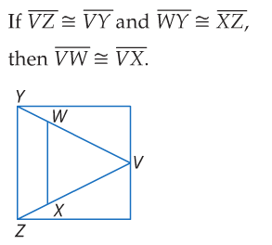

11.

|  |  |
| --- | --- |
| Statements | Reasons |
|  | 1. Given |
|  | 2. If a point is a **midpoint** of a segment, then it divides the segment into two congruent segments. |
|  | 3. Definition of Congruent Segments |
| 1. C,D,E,F,G Z are collinear | 4. Assumed by Diagram |
| 1. CD + DE = CE   FG+ EF = EG | 5. Segment Addition Property |
| 1. FG + EF = CE | 6. Substitution Property |
| 1. CE = EG | 7. Substitution Property |
|  | 8. Definition of Congruent Segments |

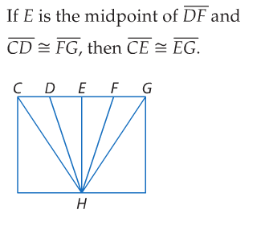

12.

|  |  |
| --- | --- |
| Statements | Reasons |
|  | 1. Given |
|  | 2. If a point is a **midpoint** of a segment, then it divides the segment into two congruent segments. |
|  | 3. Definition of Congruent Segments |
| 1. 4. A, B, C, D, E are collinear | 4. Assumed by Diagram |
| 1. AB + BC + CD + DE = AE | 5. Segment Addition Property |
| 1. AB + AB + DE + AB = AE | 6. Substitution Property |
| 1. AB + AB + AB + AB = AE | 7. Substitution Property |
| 1. 4 AB = AE | 8. Combine Like Terms |
| 1. AE= 4AB | 9. Symmetric Property |

